Claim Document Batch
DTN# should be first page endorsing string. When we scan the endorsing string is inked on the bottom of the page. That goes into our document tracking number key word.
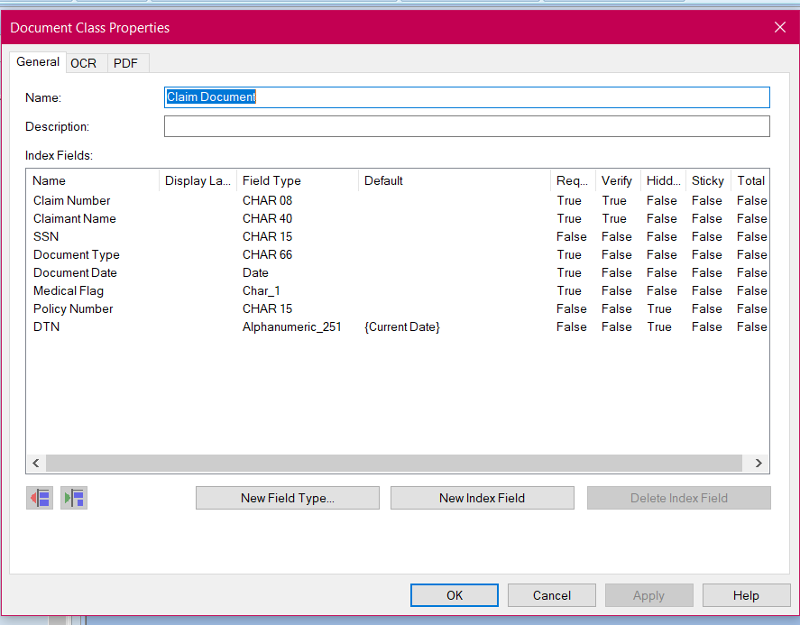
Claim Documents_KIC does not get scanned on the scanner so we do not have an endorsing # so this would need to stay as current date.

Corr Received Batch looks good
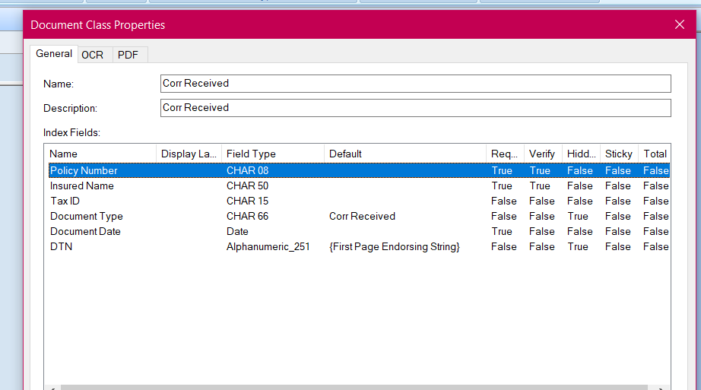

Correspondence Sent Batch looks good
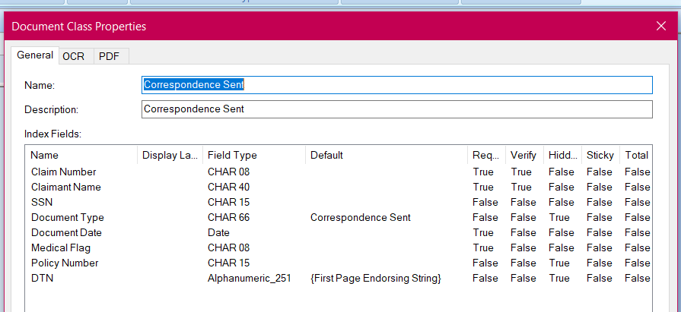

Lead Sheets Batch looks good this validation script should be the same as Claims Documents.
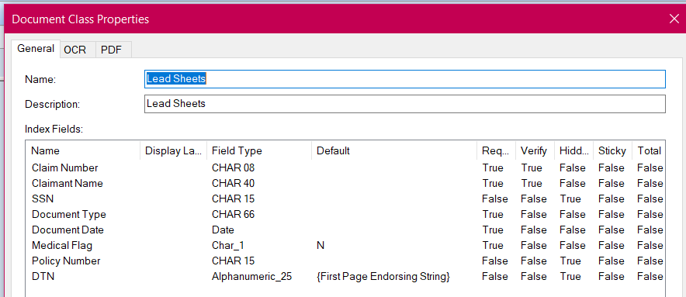

Loss Control Documents Batch looks good
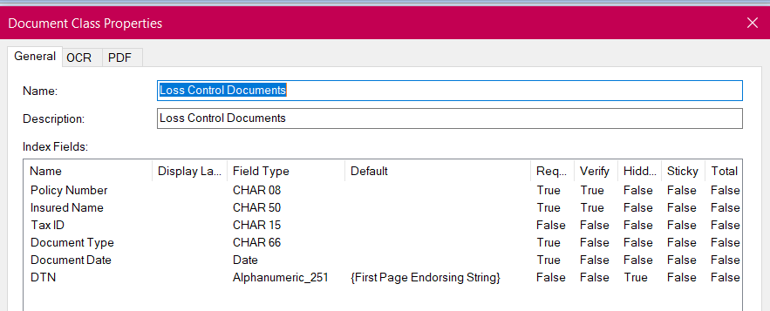

On-Demands look good
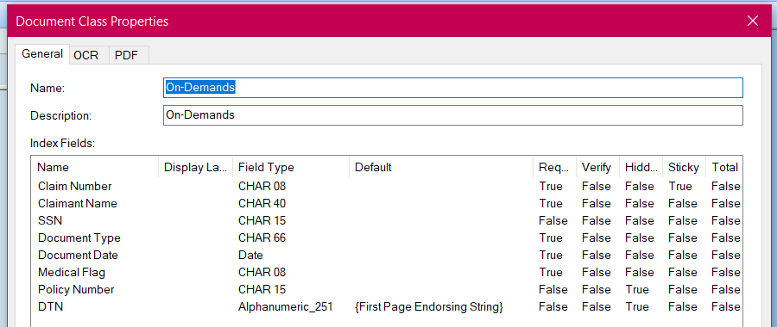

PCRB Documents Batch
Need to add the DTN# first page endorsing string
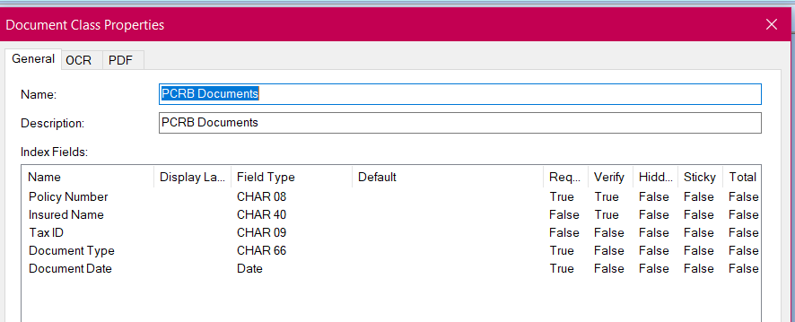

Policy backfile Batch
Need to add the DTN# first page endorsing string
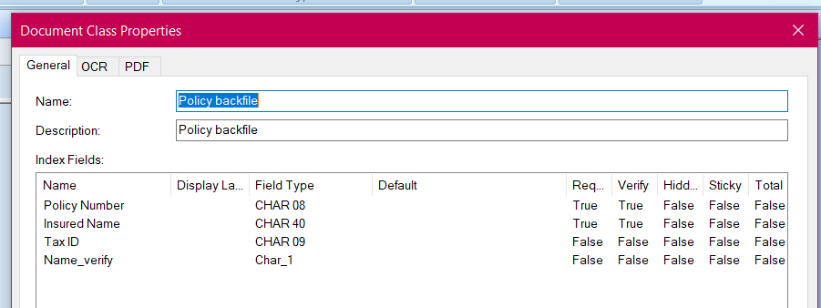

Policy Document Batch
Need to add the DTN# first page endorsing string this is also where I do not get a drop down list for policy document types only the shortcuts.
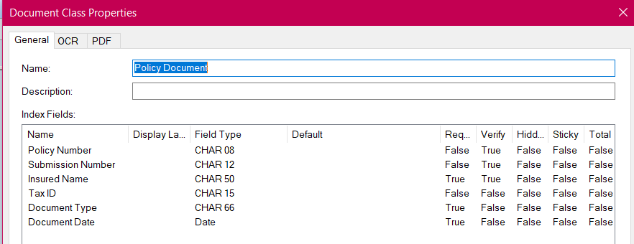

Provider Change Request Batch
I think the Provider Name needs to be True and verify false. We have to type Tax id and provider name in to both fields. There is not a autofill process for this.
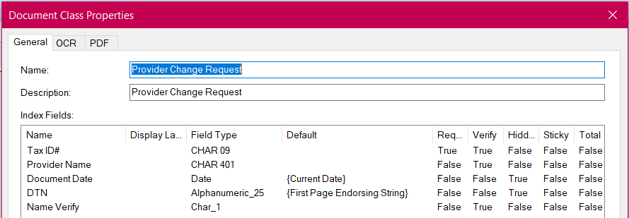

RCI’s Batch Looks good
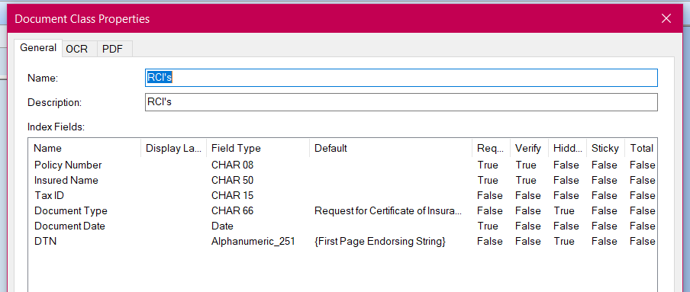

WF – Payroll Report Batch
Payroll Report Document Date should be the date we type in not current date.

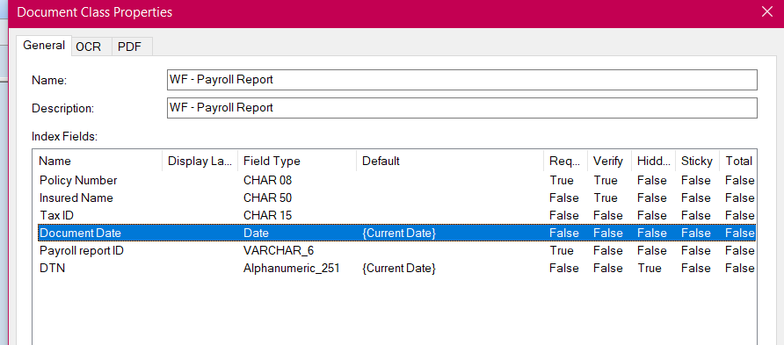

DTN is not current date.

WF - Payroll Report_KIC
does not get scanned on the scanner so we do not have an endorsing # so this would need to stay as current date.

WF – PCRB Correspondence_KIC needs name changed to WF-Policy Documents_KIC does not get scanned on the scanner so we do not have an endorsing # so this would need to stay as current date.
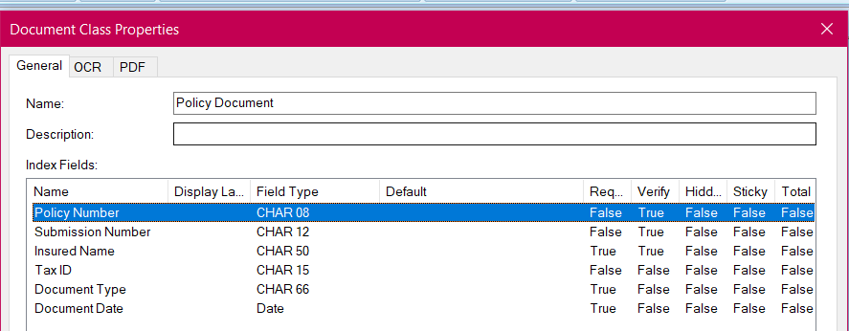

WF-Policy Documents Batch
Document Date we enter the stamp date from mailroom, so this is not going to always be current date.
Need to add the DTN# first page endorsing string
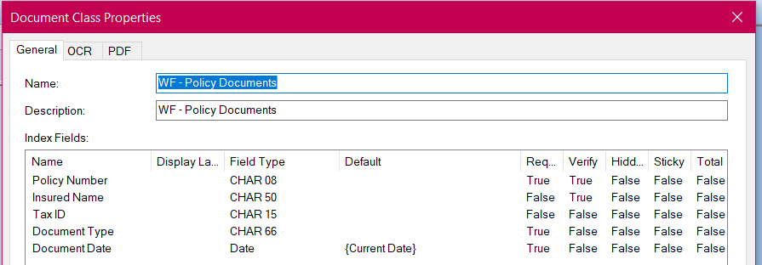

WF-QA106 – PPAF Batch
Need to add the DTN# first page endorsing string
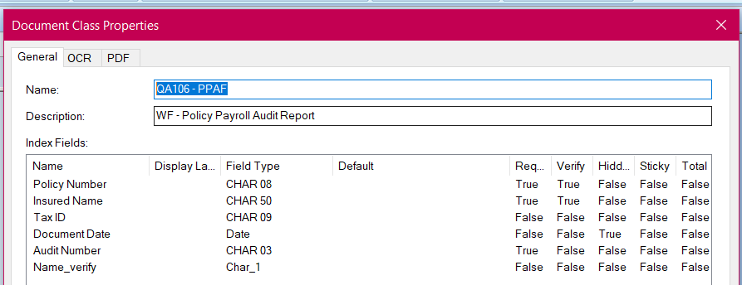

WF-Application Batch
We have never used this flag. It can be removed.
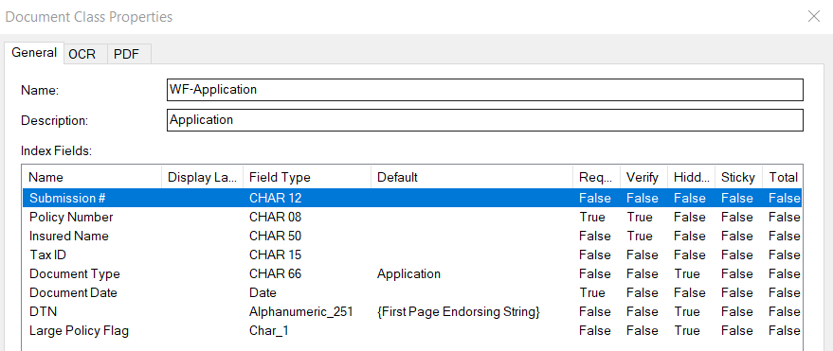

WF-HCFA Hoover Bills Batch
These are the batches that need to have the workflow flag keyword set to “Y”
I did notice that on the sticky fields that I have to still type the doc type in. It does not just let me hit enter. Example would be the WF-HCFA, WF-UB 92, WF-Prescription.

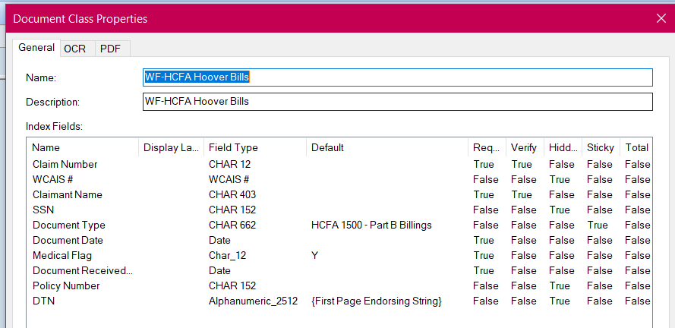

WF-Prescription Hoover Bills
These are the batches that need to have the workflow flag keyword set to “Y”
I did notice that on the sticky fields that I have to still type the doc type in. It does not just let me hit enter. Example would be the WF-HCFA, WF-UB 92, WF-Prescription.
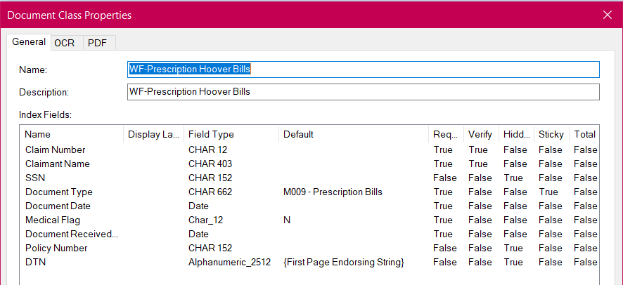

WF-UB 92 Hoover Bills Batch
These are the batches that need to have the workflow flag keyword set to “Y”
I did notice that on the sticky fields that I have to still type the doc type in. It does not just let me hit enter. Example would be the WF-HCFA, WF-UB 92, WF-Prescription.
